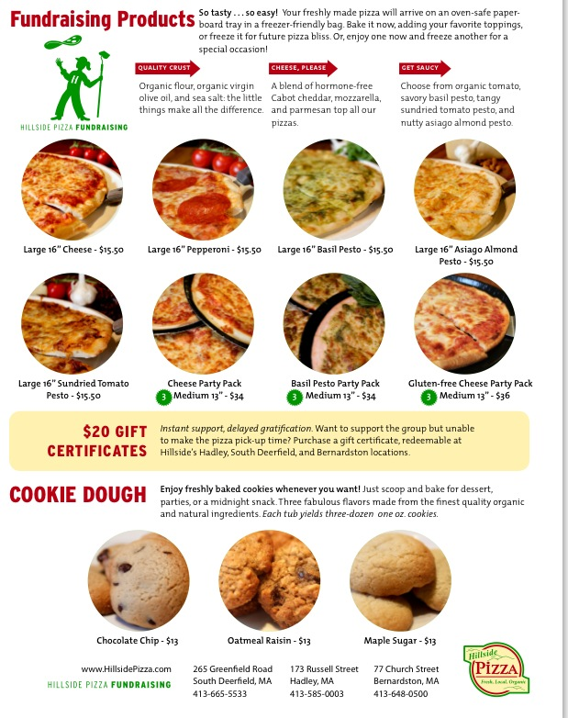
African Scholars Program Hillside Pizza Fundraiser
Order deadline: October 4 (please include payment) Order pickup at ARHS: October 9, 2:30 – 4:30 p.m.

