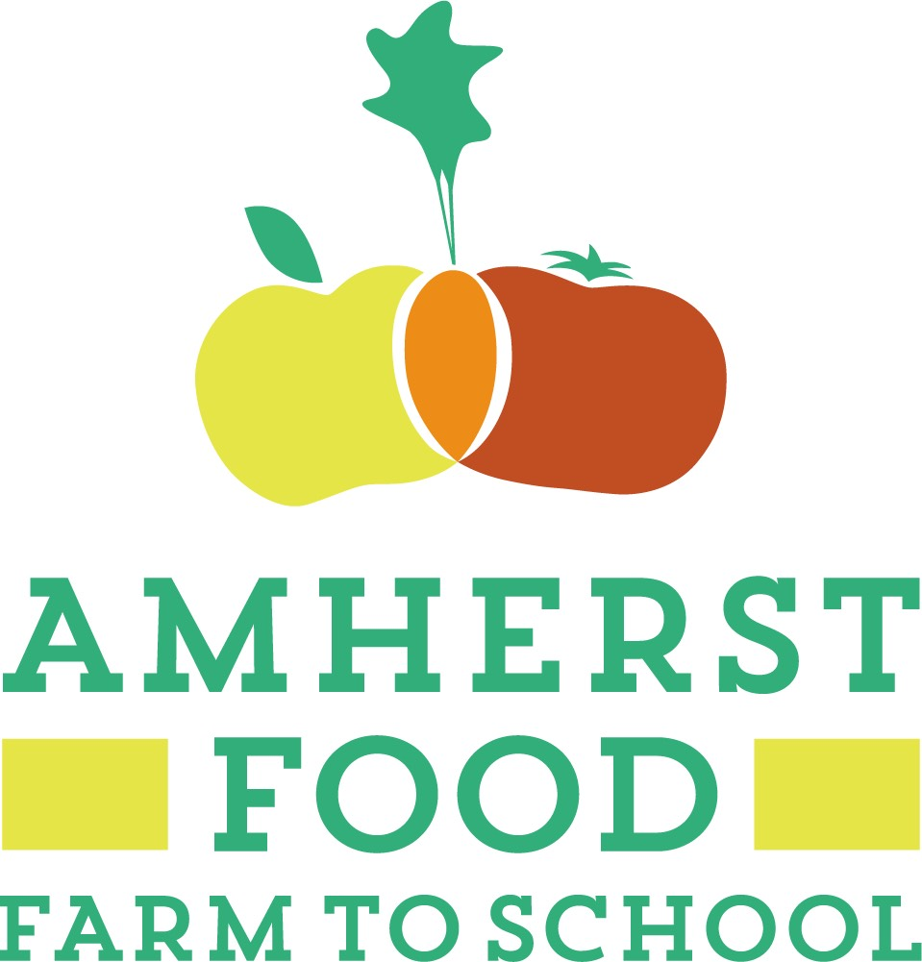  May 29, 2019  farm to School Cultural Food Exchange  Come join our Farm to School Cultural Food Exchange and help celebrate the work that has been done this past year to build a robust Farm to School (F2S) program which will link fresh food in the cafeteria to student learning in the classroom, the community, and area farms. There will also be a presentation from the F2S Team about their plan for the upcoming year!  For more information, for volunteer sign up, or to RSVP please contact:  Vicki Van Zee vanzeev@arps.org or  Julia Burdick burdickj@arps.org  Or click this link: http://bit.ly/ARPSF2S | This event is free to the public and open to children, families, and all members of the community.  ────  Come enjoy a sampling of favorite meals representing some of the diverse cultural backgrounds of ARPS School Nutrition Staff, featuring local produce.  ────  Learn about farm fresh fruits and vegetables through kid-friendly games and activities.  ────  Bring your own reusable plates and utensils to help us cut down on waste and be kind to the environment!  Amherst Regional High School Cafeteria  21 Matoon St  Amherst, Ma 01002  Wednesday, May 29  5:00-7:00 PM

